Introduction to Microsoft Access

Table of Contents
Introduction to Microsoft Access 1
Introduction 3
Create a database from scratch 3
Basic Layout of a Database 3
Tables 5
Planning your Table 6
Create a table with Table Design 6
Change the data type of a field 7
Importing Data 8
Forms 11
Create a Form 11
Editing your form 12
Queries 17
Create a query 17
Reports 20
Create a Report 20

Presented by:
ITS Training Services
Doris Selva 77270
Benjamin Virzi 77635

Introduction
A database is a computer program for storing information in an easily retrievable form. It is used mainly to store text and numbers (for example, the Library catalogue, which includes the author, title, class number and accession number for each book).
When setting up your own database, it is important to plan its use in advance. This is particularly important if you are setting one up which will be used by other people. Among the things which you should consider are:
- What information you will need to store
- What information you want to get out
- Who the data is intended for and how other users will use it
- Who is allowed to add or change data

Create a database from scratch
- Select Blank desktop database

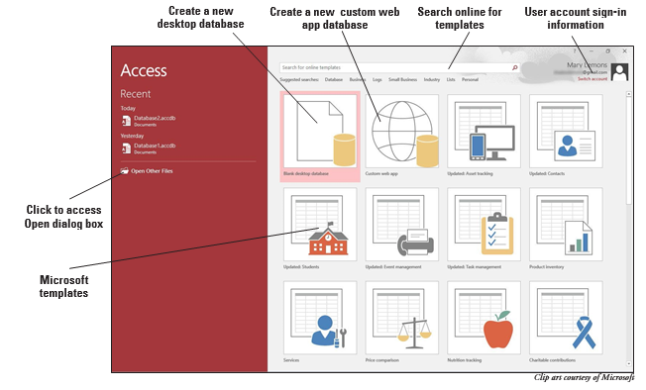
On the next screen, a Navigation Pane appears on the left. This controls navigation within a particular database. A database is consisted of several objects, grouped into a single file:

Basic Layout of a Database
- Tables - hold the raw data
- Forms - user-friendly layouts to display data on the screen (either in a table or from a query)
- Queries - extract part of the raw data to produce dynasets - dynamic sets of data which can change each time the query is run (to reflect any changes to the data in the tables)
- Reports - output files, ready for printing
- Pages - for creating/editing WWW pages
- Macros - lists of commands to perform particular functions
- Modules - programs which expert users write in a programming language called Access Basic to perform tailor-made functions not generally available
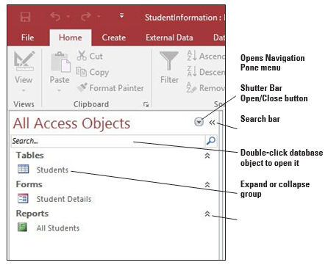

Tables
Tables store your data. For example, a list of employees/employee information (e.g. Name, ID, Department)
Data types Definition:
Data Type | Example | Description
Short Text | Last Name: D’Amato Street: 1234 Landau Ave. | The most common data type for fields. Can store up to 255 characters of text, and numbers (or a combination of both).
Long Text | Comments: Student will make monthly payments on the 15th of each month of  $247. | Stores large amounts of text—up to 1 gigabyte (GB)  —but only the first 64,000 characters of text, and numbers (or a combination of both) will be visible on the screen. Approximately 18 pages of data
Number | Age: 19  Grade: 95.5 | Stores numeric data that can be used in mathematical calculations.
Date/Time | Birthday: September 5, 1972 | Stores date and/or time data.
Currency | Registration Fee: $50.00 | Stores monetary data with precision to four decimal places. Use this data type to store financial data and when you don’t want Access to round values.
AutoNumber | Student ID: 56 | Unique values created by Access when you create a new record. Tables often contain an AutoNumber field used as the primary key.
Yes/No | Insurance: Yes | Stores Boolean (true or false) data. Access uses 1 for all Yes values and 0 for all No values.
OLE Object | Photo | Stores images, documents, graphs, and other objects from Office and Windows-based programs.
Hyperlink | Web addresses | Stores links to websites, sites or files on an intranet or Local Area Network (LAN), and sites or files on your computer.
Attachment | Any supported type of file | You can attach images, spreadsheet files, documents, charts, and other types of supported files (up to 2 GB per record) to the records in your database, much like you attach files to email messages.
Calculated | FullName: John Derenzo | Stores an expression based on two or more fields within the same table.  Example using concatenation operator (&): First: John  Last: Derenzo  FullName stored as: [First]&” “&[Last]
Primary Key |  | This is a specific field that uniquely identifies each record in the table.
Foreign Key |  | In the context of relational databases, a foreign key is a field (or collection of fields) in one table that uniquely identifies a row of another table or the same table. In simpler words, the foreign key is defined in a second table, but it refers to the primary key or a unique key in the first table.
Flat file database |  | In a flat system (also known as a flat-file system), all the data is lumped into a single table.
Relationship database. |  | The relational system (or relational database) uses as little storage space as possible by cutting down on the duplicated (also known as redundant) data in the database.

Planning your Table
- What is the end goal of your database?
- What information you will need to store
- Are you going to need more than one table?
- What is the datatype each field?
- What kind of field properties do you want for each field?
- What information you want to get out
- Who the data is intended for and how other users will use it?

Create a table with Table Design
- Select Create > Table Design.
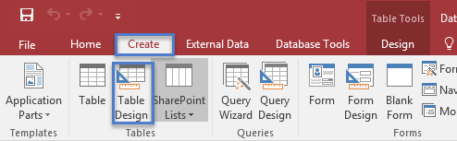

- In the new table, for the first field, enter a field name and a data type.
Note: Access does not process spaces like word and excel does. It you would like to separate words use an underscore “_”.
- Select the Save icon, and name the table. (Employee Info)
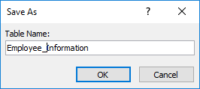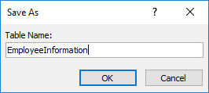
When you try to close the database, if you have not saved your work on a table, Access prompts you to save it. Alternatively, at any time, select Save.
Note: Microsoft Access does not Autosave your progress like Word or Excel. I would recommend that you save as often as possible.

Change the data type of a field
When you add a field by typing data into it, Access sets the field’s data type based on its contents. View the data type on the Fields tab, under Data Type.
To change the data type:
- Select the field.
- On the Fields tab, open the Data Type list and select a data type.
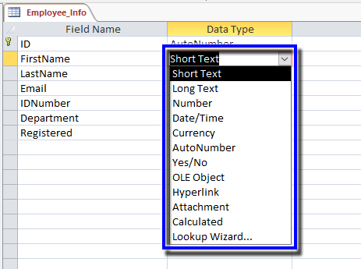

Importing Data
- Select External Data, and select Excel.
  - You must have an Excel document saved to upload.
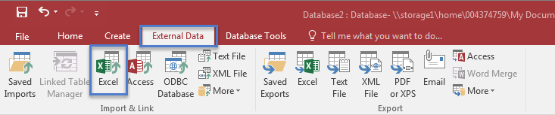

- The Get External Data page appears.
- Select Browse, then select the file you want to open.
- Select the Import the source… and select Ok.
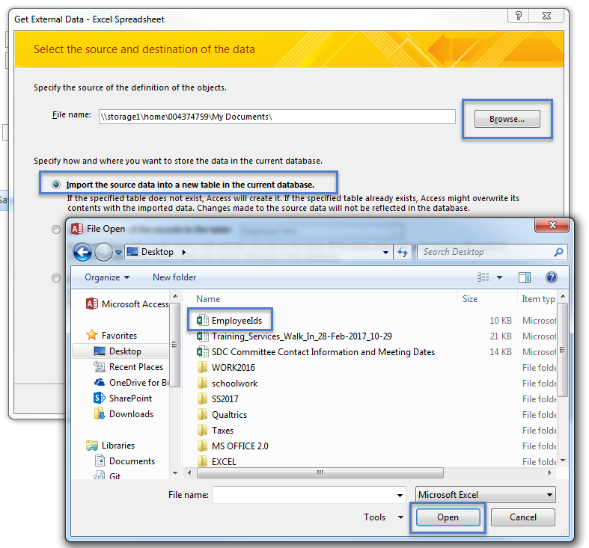

- The Import Spreadsheet Wizard will display with the information.
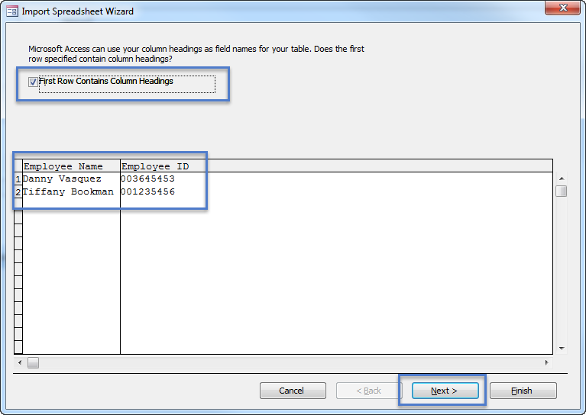
- Edit the field options and select Next.
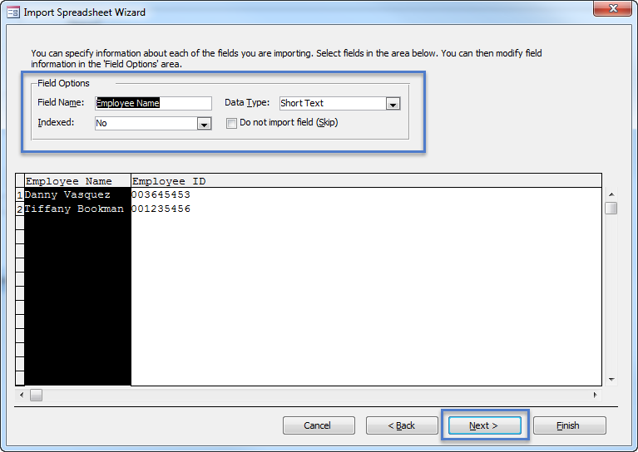
- Next, select No primary key, then select Next.
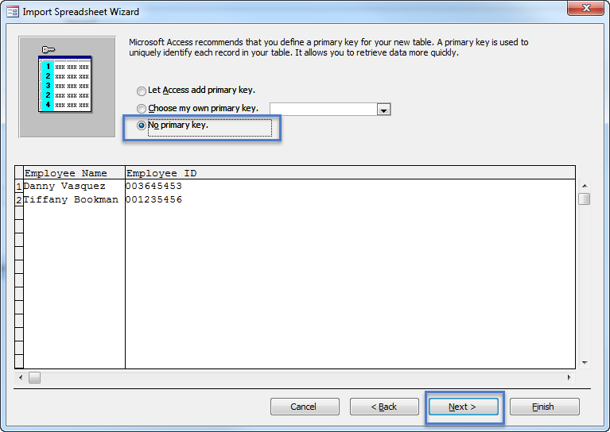

- Name the table, and select Finish.
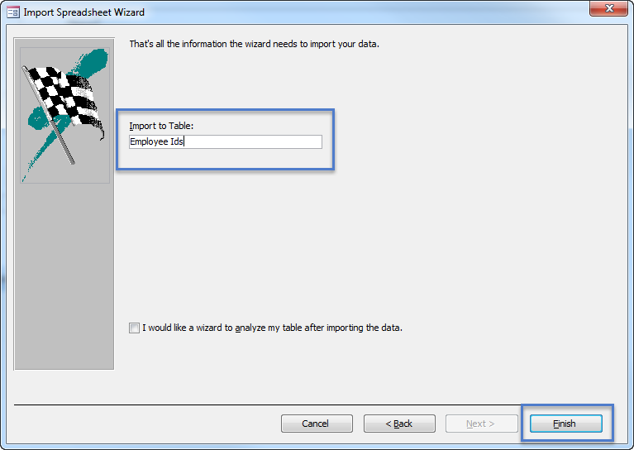

- Lastly, you can save the import method or select cancel.

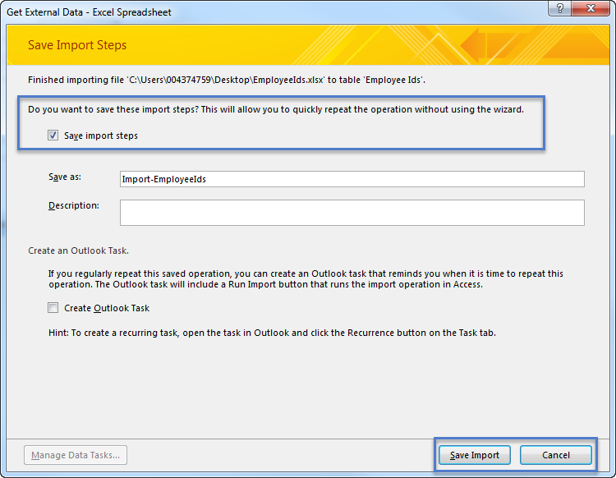
- Your table will be displayed under Tables:
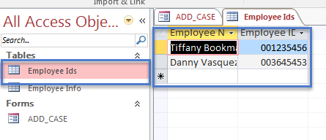

Forms

Create a Form:
- Open the desktop database in which you want to add a navigation form.

- On the Create tab, in the Forms group, select Form Design or any that you would like to choose.
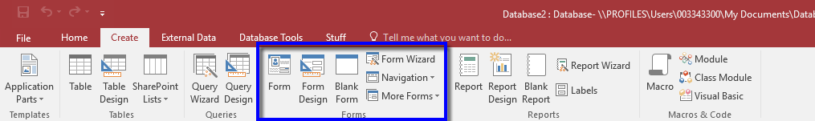
- Select Form Design located under Form Design Tools to modify your Form.

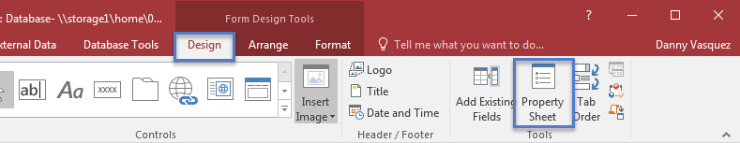

Editing your form

Fields
- Select Add Existing Fields under the Design tab when in Design view.
  - To select all of the fields: Select the first field, then hold down Shift on your keyboard and select the last field.
- Next, drag and drop the fields into the form.

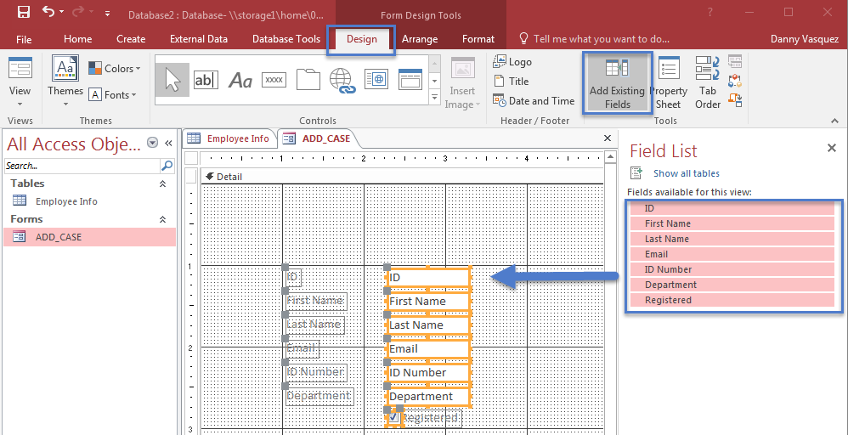

- Select the fields you would like to rearrange or once you have select the fields use the arrows on your keyboard to move the fields.
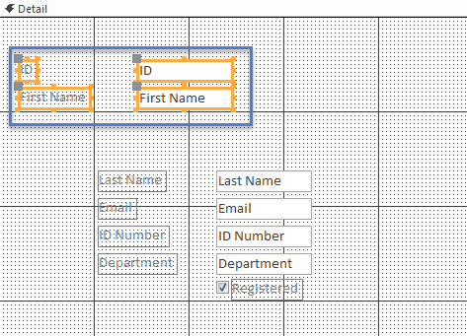

Command Buttons
- Select the button icon located in the controls field.
- Then, hover over the form and select where you would like to place the button.
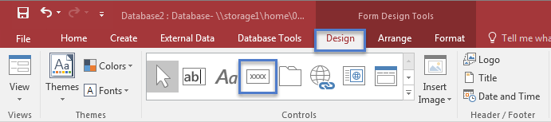

- The Command Button Wizard will display
- Select Record Operations or whatever you are looking for, and select the appropriate action you are looking for.
- Select Next

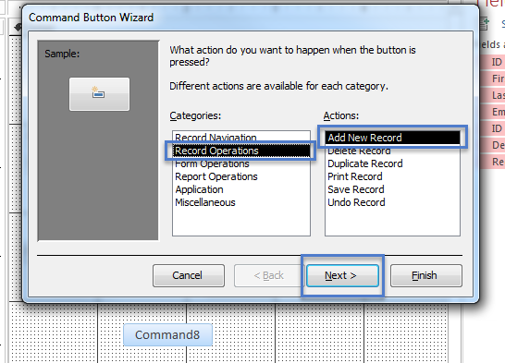

- Select Text or picture then name button and select next.

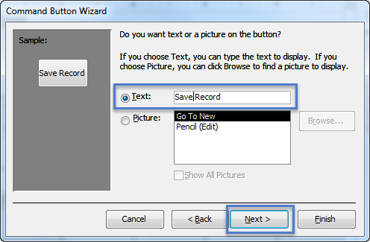

- Name the button for reference and select Finish.

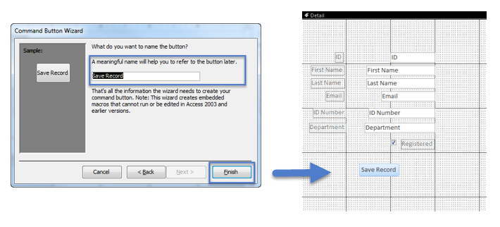

- Next Select View, your form will display.
- Enter data and select Save Record.
- The record will be added to the table associated with the form.
  - To view: Select the table, and the record will display.
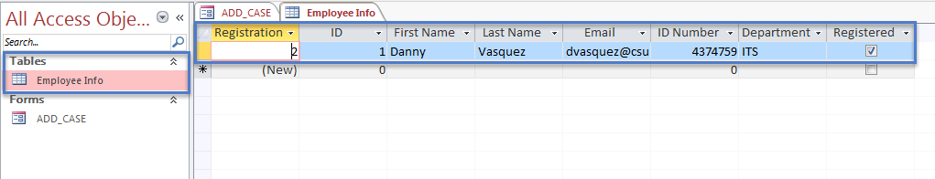

Reports

Create a Report
View, format, and summarize the information in your database with reports.
- Select Blank Report under the Create tab.
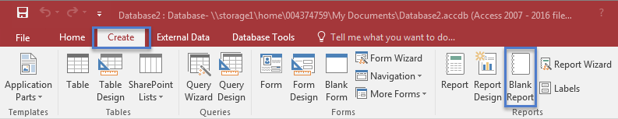
- Select the View dropdown, then select Design View.
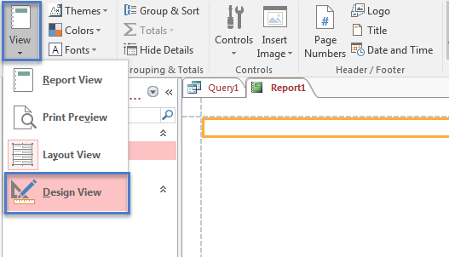
- Select Design, then select Property Sheet. Under the property sheet menu select the Data tab, then select the table you would like to run the report for under Record Source.
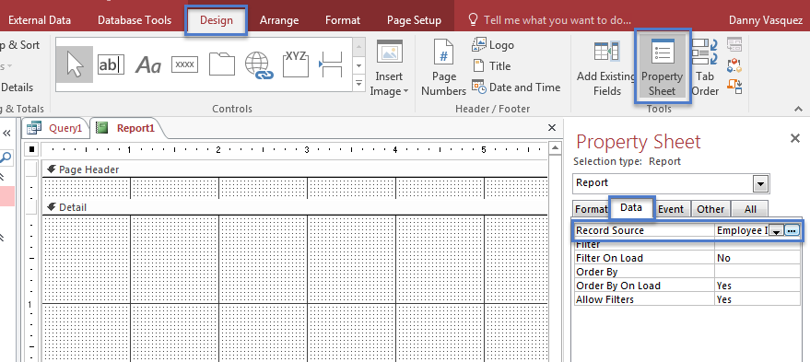
- In the ribbon, select Add Existing Fields. Then drag and drop the fields from the field list you want to display in the report.

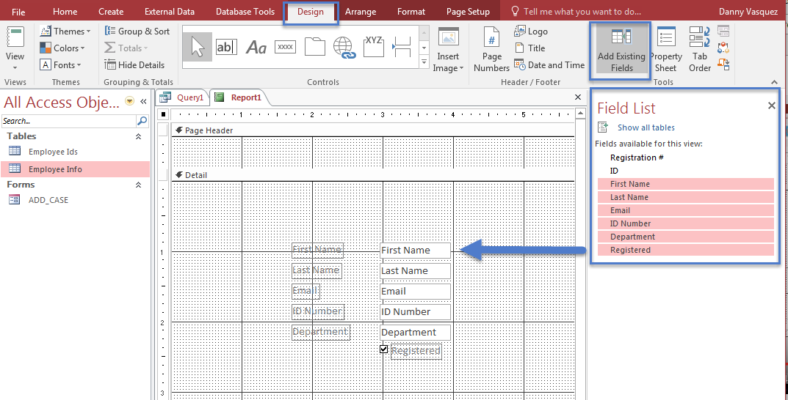

To create headers/footers for your report:
- Drag the header/footer to the size needed.
- Then select the label control from the control area and click inside the header section.

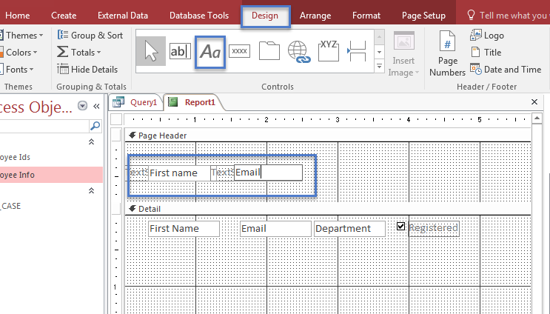

- Select View and your report will be displayed.

